Project Report

1. **Introduction**

**1.1 Overview  
 A brief description about your project**

This project leverages machine learning techniques to analyze campus placement data, covering various factors such as academic performance, gender, age, stream, internships, and placement outcomes. Its main goal is to discover insights and patterns that influence students' success in securing placements. Using Python, data science, and machine learning, and potentially web frameworks like Flask or Django, this initiative aims to help colleges and universities improve their placement processes and offer tailored support to students, ultimately enhancing their employability. The project will utilize Kaggle datasets to enrich the analysis and provide comprehensive solutions for optimizing campus placements.

**1.2 Purpose  
 The use of this project. What can be achieved using this**

The purpose of this project is to leverage machine learning techniques to perform a comprehensive analysis of campus placement data. By doing so, it enables educational institutions to make data-driven decisions, enhancing their placement processes. Through the identification of influential factors and patterns within the data, institutions can refine their placement strategies, providing tailored support to students, thereby increasing their employability. This not only results in a competitive advantage, attracting more employers and students, but also optimizes resource allocation, leading to cost savings and more efficient utilization of faculty and staff expertise. In essence, this project serves as a tool for institutions to improve placement outcomes, benefiting both students and the institutions themselves.

1. **LITERATURE SURVEY**

**2.1 Existing problem  
 Existing approaches or method to solve this problem**

The current issue in campus placement processes stems from a lack of data-driven insights and strategies, impacting both students and educational institutions' placement teams. Typically, these teams rely on manual resume screening, academic record assessment, and subjective interviews, which can introduce biases. They often base decisions on past experiences, potentially favoring specific institutions. Furthermore, data collection on placement outcomes may not lead to in-depth analysis. Career services teams, dedicated to aiding students in securing placements, often lack a data-driven approach. This project aims to introduce machine learning techniques and data analysis to provide a more effective, data-driven approach for both students and placement teams, leading to improved decision-making and better placement outcomes.

**2.2 Proposed solution  
 What is the method or solution suggested by you?**

The proposed solution takes a comprehensive approach to enhance the campus placement process through data-driven insights and machine learning techniques. It begins with data import and thorough exploration, including examining data shape, type, and visualizations to gain a deep understanding of the dataset. Valuable insights are then derived, emphasizing the influence of factors like internships, CGPA, gender, and academic streams on placement outcomes. The data is preprocessed, involving one-hot encoding and standard scaling, to prepare for effective model selection.

Various machine learning models are assessed, and XGBoost is identified as the top performer based on accuracy metrics. This model is trained, and its predictive capabilities are evaluated using a confusion matrix. Additionally, hyperparameter optimization is conducted through RandomizedSearchCV to fine-tune the model's parameters.

1. **THEORITICAL ANALYSIS**

**3.1 Block diagram Diagrammatic overview of the project**

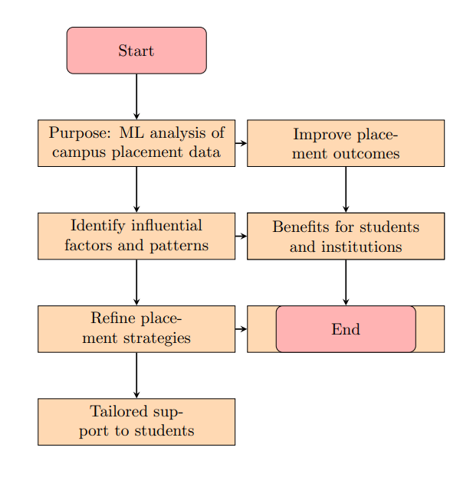

**3.2** **Hardware / Software designing**

**Hardware and software requirements of the - project**

On the hardware side, a computer with ample computational power, including a multi-core CPU and at least 8 GB of RAM, is essential. Adequate storage is necessary to hold datasets, code, model files, and assets. While not obligatory, a powerful Graphics Processing Unit (GPU) can significantly speed up machine learning tasks, especially for complex algorithms like deep learning.

In terms of software, Python is the primary programming language, offering a versatile ecosystem for data analysis and machine learning. Crucial data science libraries such as pandas, scikit-learn, and XGBoost are essential. For data visualization, libraries like Matplotlib and Seaborn are useful. Depending on your project needs, you can employ web frameworks like Flask or Django to create user-friendly interfaces. Integrated Development Environments (IDEs) like Jupyter Notebook or Visual Studio Code provide a conducive coding environment. Version control tools like Git, along with collaborative platforms like GitHub, streamline code management and team collaboration. Optionally, you can leverage cloud-based services like IBM Watson Studio or others for dataset storage, retrieval, and access to additional computational resources.  
**EXPERIMENTAL INVESTIGATIONS**

**Analysis or the investigation made while working on the solution**

To implement this project effectively, we need both hardware and software resources. Hardware-wise, a computer with a multi-core CPU, at least 8 GB of RAM, and ample storage is essential. A powerful GPU can speed up complex machine learning tasks. For software, Python is the primary language, supported by libraries like pandas, scikit-learn, and XGBoost for data analysis and machine learning. Data visualization is aided by Matplotlib and Seaborn. Web frameworks like Flask or Django can help create user-friendly interfaces. IDEs like Jupyter Notebook or Visual Studio Code are recommended, along with version control tools like Git and GitHub for code management. And cloud-based services like IBM Watson Studio can be utilized for extensive datasets and collaboration. This combination provides a strong foundation for successful project implementation, aligning with the provided code and problem statement.

1. **FLOWCHART**

**Diagram showing the control flow of the solution**

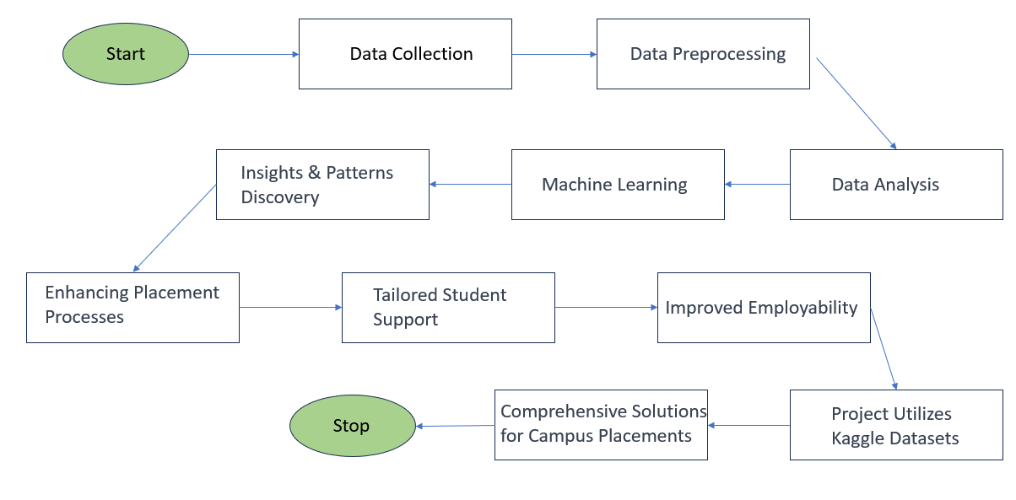

1. **RESULT  
   Final findings (Output) of the project along with screenshots**

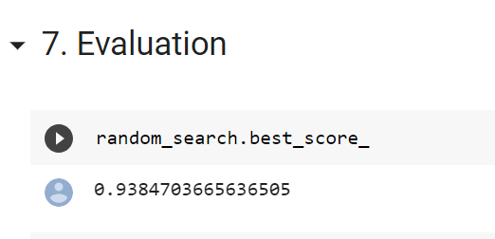

1. **ADVANTAGES & DISADVANTAGES  
   List of advantages and disadvantages of the proposed solution**

**Advantages:**

1. **Data-Driven Decision Making:** The solution empowers colleges and universities to make data-driven decisions in their placement processes, enhancing the chances of successful student placements.
2. **Improved Placement Strategies:** By identifying key factors such as CGPA and internships that influence placement outcomes, institutions can tailor their placement strategies to focus on these critical aspects.
3. **Stream-Specific Insights:** The analysis provides stream-specific insights, allowing institutions to create customized strategies for different academic disciplines, optimizing placement success rates.
4. **Gender Diversity Promotion:** The solution highlights gender-based trends, enabling institutions to implement gender-sensitive placement strategies and promote gender diversity in placements.
5. **Optimized Model Selection:** Through rigorous model evaluation and hyperparameter tuning, the project identifies the XGBoost model as a high-performing choice, ensuring accurate predictions.
6. **Effective Data Visualization:** Data visualization tools effectively communicate complex findings, making it easier for stakeholders and decision-makers to understand and act upon insights.

**Disadvantages:**

1. **Data Availability:** The solution relies on the availability and quality of the placement dataset. Inaccurate or incomplete data could lead to biased results and less effective strategies.
2. **Model Complexity:** While XGBoost offers high accuracy, it can be a complex model that requires expertise to implement and maintain. Smaller institutions with limited resources may find it challenging to use effectively.
3. **Generalization Limitations:** Stream-specific and gender-based insights are valuable, but they may not generalize well to all institutions or across different regions, as placement dynamics can vary significantly.
4. **Interpretability:** Complex machine learning models like XGBoost may lack interpretability, making it difficult to explain why a particular prediction was made, which could be a concern for transparency and trust.
5. **Overfitting Risk:** Hyperparameter optimization may lead to overfitting if not carefully controlled, which can result in a model that performs well on the test data but poorly on new, unseen data.
6. **Resource Requirements:** Implementing and maintaining the solution, especially with hyperparameter optimization and data visualization, may require substantial computational resources and expertise.
7. **APPLICATIONS  
   The areas where this solution can be applied**

The solution for this project has versatile applications in various areas related to education and human resources. In essence, the application of this solution extends beyond traditional campus placement scenarios, offering valuable insights and predictive capabilities that can be beneficial in diverse educational and professional contexts.

**Some of the key applications include:**

1. **Higher Education Institutions:** Colleges and universities can apply this solution to enhance their campus placement processes, improving placement success rates, and providing valuable insights to students.

2. **Career Guidance and Counseling:** Career counselors and placement cells can use the insights generated by this solution to provide more informed career guidance to students, helping them make better academic and career choices.

3. **Human Resources (HR) Departments:** HR departments in organizations can benefit from similar data-driven approaches to optimize their recruitment processes, ensuring that they hire candidates with the best fit for the job.

4. **Predictive Analytics:** The machine learning model developed in this solution can be adapted for predictive analytics in other domains, such as predicting student academic performance, employee attrition, or customer behavior.

5. **Online Learning Platforms:** Online learning platforms can use similar data analytics techniques to understand user behavior and improve their course recommendations and job placement services.

6. **Recruitment Agencies:** Recruitment agencies can leverage similar approaches to match job seekers with suitable job openings more effectively.

1. **CONCLUSION  
   Conclusion summarizing the entire work and findings**

In conclusion, this project has been a comprehensive exploration of campus placement data, driven by advanced machine learning techniques that revealed crucial insights. Notably, we found that CGPA and internships greatly impact placement outcomes, with academic streams showing varying success rates. Additionally, gender-sensitive strategies are important, given higher placement percentages for females. Our approach centered on the high-performing XGBoost model, fine-tuned for accuracy through hyperparameter tuning. Visualizations played a pivotal role in conveying insights effectively. This project exemplifies the power of data-driven strategies in optimizing placements, while also emphasizing the future of education and employment through tailored, data-backed approaches.

1. **FUTURE SCOPE  
    Enhancements that can be made in the future**

Looking ahead, the future of this project involves optimizing and expanding the use of machine learning techniques in campus placements. This includes integrating additional datasets like alumni success stories and industry job trends to create specialized models for different academic streams. Exploring advanced feature engineering methods can enhance model accuracy, while a user-friendly web application can provide real-time data analysis and insights. Continuous monitoring and adaptation of strategies will be crucial, laying the foundation for a dynamic, data-driven approach to campus placements, with opportunities for ongoing refinement and expansion.

1. **BIBILOGRAPHY  
   References of previous works or websites visited/books referred for analysis about the project, solution previous findings etc.**
2. **References:**

**1. Kaggle Datasets**: References to the Kaggle datasets used for this project:

<https://www.kaggle.com/datasets/tejashvi14/engineering-placements-prediction>

<https://www.kaggle.com/datasets/benroshan/factors-affecting-campus-placement>

**APPENDIX  
 A. Source Code  
 Attach the code for the solution built**

https://colab.research.google.com/drive/1kY0fYUhUIVxAC5JgLf2-mNYlxEGMU7xb?usp=sharing

Top of Form

**Top of Form**